**Git Commit Message**

Concise & consistent, instead of length & form

1. Separate subject from body with a blank line
2. Limit the subject line to 50 characters
3. Capitalize the subject line
4. Do not end the subject line with a period
5. Use the imperative mood in the subject line
6. Wrap the body at 72 characters
7. Use the body to explain what and why vs. how

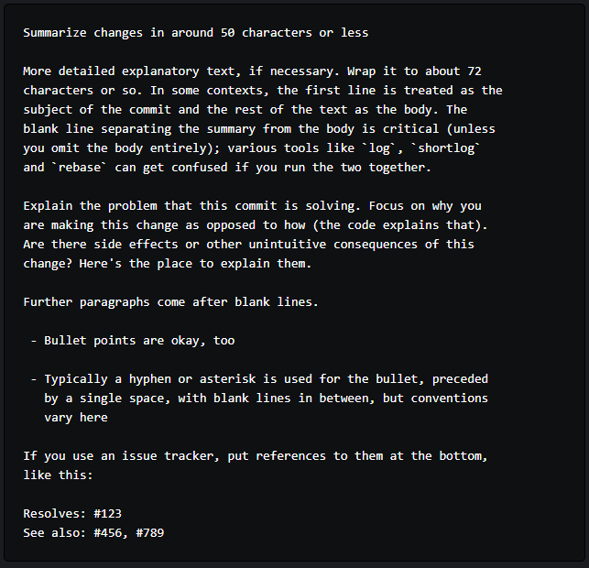

For something simple, its easier to use *-m* to *git commit*:

$ git commit -m"Fix typo in introduction to user guide"

*git log –oneline* prints out just the subject line

*git shortlog* groups commits by user, showing just the subject line for concision

Commit subject line should be in the form of “do something”

If applied, this commit will your subject line here